Daniel Shu

Student Managed Portfolio Project

Professor Ramezani

9 March, 2017

Walmart (WMT)

Table of Contents

Abstract…………..…………….………………………………………………………….1

Executive Summary/Company Overview............................................................................2

Industry outlook/company prospect.................................................................................... 3

Macroeconomic factors………………………………………………………………..…..4

Valuation/financial Analysis…………………………………………...……………….5-7

DCF Model…...………………………………………………………………………..….8

Investment Risks…………………………………………………………...…….…….….9

Recommendation/Conclusion………………...………………………………………….10

Appendix...………………………………………………………………………..……...11

**Executive Summary**

Wal-Mart is an American international retail chain that operates as retail and wholesale, consisting of discount department stores and grocery stores. As the largest retailer in the world in regards to profit, assets and market values, the company has offered an assortment of products and services from a wide variety at low prices for over 50 years. Wal-Mart commands operations in 28 countries outside the United States and nearly 260 million customers visit their 11,500 stores and e-commerce sites every week. In the fiscal year 2016, Wal-Mart reported revenues of $482.1 billion and currently employs 2.3 million associates worldwide – 1.5 million in the U.S. alone.

**Business Overview/Strategy**

Wal-Mart relies on their low prices to keep customers happy and to ensure that they are beating the other retailers. It thrives and operates mostly as a brick-and-mortar retail franchise but are making endeavors to grow their e-commerce. The three operating segments for the company include Wal-Mart U.S., Wal-Mart International, and Sam’s Club. Wal-Mart reported on January 31, 2017 the unit counts for each segment with 4,672 Wal-Mart US units, 660 Sam’s Club units and 6,363 Wal-Mart International units.

**Wal-Mart US**

Wal-Mart US is the largest segment and operates in all 50 states in the US, Washington DC and Puerto Rico, with 3 primary store formats. Wal-Mart US offers many products and services including groceries, apparel, household items, accessories, and more. Notably, Wal-Mart US’s most profitable sector of their stores are the grocery line, making them not only the world’s largest retailer but also the world’s largest grocery sector. In 2016, Wal-Mart U.S. generated 62% of Wal-Mart’s total net sales.

**Wal-Mart International**

Wal-Mart International is the second largest segment that Wal-Mart commands and generated about 26% of total net sales. It consists of operations in 26 countries outside the US.

**Sam’s Club**

Sam’s Club consists of membership-only warehouse clubs and operates in 48 states in the US. Membership income is a significant component of the segment’s sales, which make up 12% of Wal-Mart’s total net sales.

**Company News**

**Shares Buyback 2015**

The Board of Wal-Mart approved a $20 billion share repurchase program in October 2015, which the company plans to complete by the end of the fiscal year 2017. Annual EPS is projected to be around $4.34 for 2017, down 4.6% from $4.55 in 2016.

**Acquisition of Jet.com**

On August 6th, 2016 Wal-Mart Stores, Inc. and Jet.com, Inc., the online retail store, announced that they have made a definitive agreement for Wal-Mart to acquire Jet for 3 billion dollars in cash. Additionally, 300 million dollars of Wal-Mart shares will be paid over time. The deal, which was the largest ever for an online startup, gives Wal-Mart access to Jet’s innovative pricing software. It was part of an effort for Wal-Mart to compete with the likes of Amazon, the leader of online retailing e-commerce in the nation. Furthermore, the founder of Jet has been put in charge of the company’s entire online operations. This is Wal-Mart’s biggest endeavor to compete with Amazon, which has dominated the e-commerce industry, whose dominance is comparable, if not more dominant, to Wal-Mart in the brick-and-mortar industry. Wal-Mart has been struggling to keep up in the online retailing business, as their e-commerce share of total sales commands only 2.8% of their total sales, whereas Amazon’s e-commerce controls 74.1% of their total sales. Amazon’s e-commerce sales were nearly $80 billion whereas Wal-Mart’s were approximately $13.5 billion. On the other hand, Jet.com, Inc. is one of the fastest growing e-Commerce companies in the United States. While many praised Wal-Mart for this decision as an effort to trump Amazon, some analysts were skeptical, claiming while that Jet.com is on pace to hit $1 billion in annual revenues, Amazon is already on pace to exceed $100 billion in annual sales this year, emphasizing the insignificance the deal would have on the financials. They also argued that Jet is far from profitable due to their enormous spending on advertising which takes away much of their potential for profits.

“We’re looking for ways to lower prices, broaden our assortment and offer the simplest, easiest shopping experience because that’s what our customers want,” said Doug McMillon, president and CEO, Wal-Mart Stores, Inc. “We believe the acquisition of Jet accelerates our progress across these priorities. Walmart.com will grow faster, the seamless shopping experience we’re pursuing will happen quicker, and we’ll enable the Jet brand to be even more successful in a shorter period of time. Our customers will win. It’s another jolt of entrepreneurial spirit being injected into Walmart.”

“We're moving with speed to become more of a digital enterprise and better serve customers. We had a very solid fourth quarter with U.S. comp sales growth of 1.8 percent and U.S. e-commerce GMV growth of 36 percent. Our international business is consistently delivering solid sales growth in constant currency, and Sam's Club posted its best comp sales growth of the year. I want to thank our talented associates for their work. We have more work to do, but I'm pleased with our progress.”

Doug McMillon, President and CEO, Wal- Mart Stores, Inc.

**Earnings & Dividends Coverage**

Wal-Mart Stores, Inc. approved an annual cash dividend for fiscal year 2018 of $2.04 per share, an increase of 2 percent from the $2.00 per share paid for the last fiscal year. The fiscal year 2017 cash dividends will be paid out in four quarterly installments of $0.51 per share. This marks their 44th consecutive year of increasing their annual dividend. In the fiscal year 2017, Wal-Mart returned $14.5 billion to shareholders in the form of dividends and share repurchases. On February 21, 2017 Wal-Mart reported 4th quarter earnings of fiscal year 2017 of $130.9 billion, a 1% increase. Breaking the earnings down, Wal-Mart US sales had a 2.8% increase from last year’s 4th quarter, Wal-Mart International had a 5.1% decrease from last year, and Sam’s Clubs net sales increased 3% from last year. Furthermore, Wal-Mart had a very solid fourth quarter with US comp sales growth of 1.8% and US e-commerce GMV growth of 36%. Total revenue for fiscal year 2017 was $485.9 billion, an increase of 0.8% from the prior year. Operating income was $22.8 billion, a decrease of $5.6%

**Layoffs and increase in minimum wage**

On February 20, 2016, all Wal-Mart employees officially earned at least $10 an hour. As of January 2017, Wal-Mart announced that it will lay off hundreds of employees in order to cut expenses and grow itself.

**Industry Outlook**

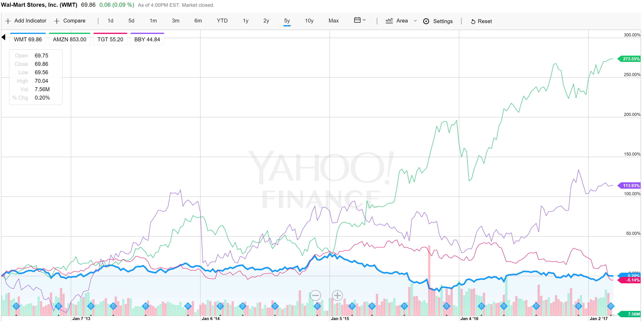

**Competition with Amazon**

In 2015, Wal-Mart first began testing the ShippingPass, which offered 3-day shipping for $50 a year. In 2016, Wal-Mart changed this plan to 2-day shipping for $49 to compete with Amazon’s Amazon Prime, which offers 2-day shipping plus many perks for $99 a year. Wal-Mart also offered free monthly trials but evidently, this strategy to try to beat Amazon was too little, too late as customers had already established a customer loyalty relationship with Amazon Prime, which arrived a few years before ShippingPass did.

As of February 27, 2017, Wal-Mart has taken the bold step of dropping its $50 annual Amazon Prime-like ShippingPass program. The company instead now offers free 2-day shipping on orders over $35 as another attempt to downplay Amazon Prime’s $99 annual fee.

**Retail industry growth**

According to an article on Kiplinger, strong retail sales growth in January of 2017 indicate that consumers are still bullish on the economy. Excluding gasoline, retail sales in 2017 are expected to rise 3.9%, slightly above the growth rate in 2016.

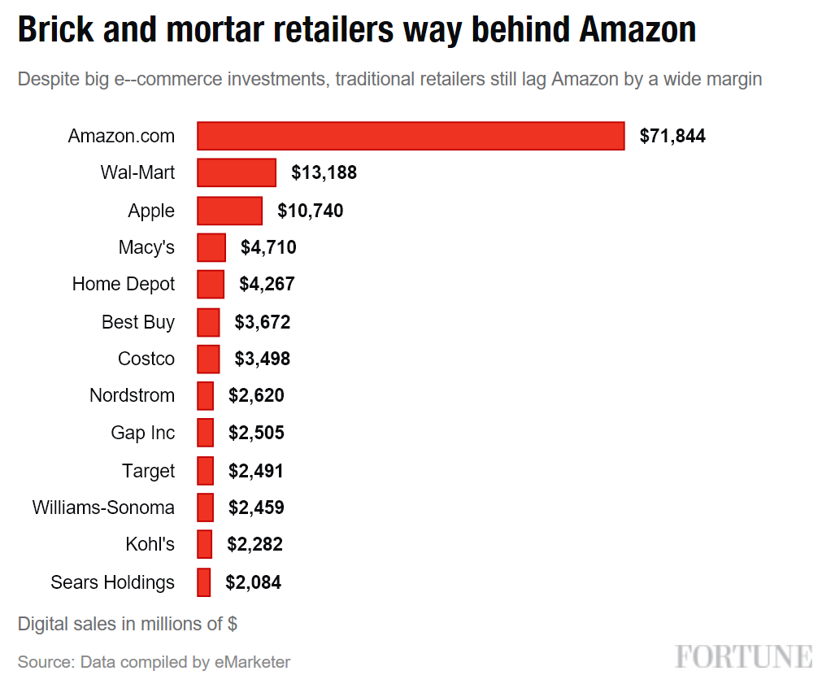

**Analyst Opinion**

As the biggest brick-and-mortar retail company in the world, Walmart prioritizes growth through many methods, including improved in-stock levels, a more aggressive pricing strategy, better customer service and increased customer convenience from growth in e-commerce product offerings. The growth in the e-commerce sector is instrumental to Walmart’s business operations. The online business sales are expected by Capital IQ to increase by 15% the upcoming fiscal year. Not only is it already the largest business in the world based on annual revenues alone of $483 billion but the company also shows great potential in its growth prospect. With over 11,000 locations around the world, Walmart continues to expand and dominate with its “Everyday low prices” slogan.

The company offers great assurance and consistency through its incessant annual dividend growth. After 43 years, the dividends are still growing yearly, and it doesn’t appear as though Walmart is going to break that trend. Overall, most analysts are rating Walmart as a hold or buy and noting that it’s a solid company to have in one’s portfolio due to its consistency and risk averseness. Historically, Walmart’s stock shows to be fairly unwavering over the past several years.

I believe Walmart is a stock that the management team should consider holding due to Walmart’s potential, especially after the acquisition of Jet so we are due to see a change in the performance of the company. Walmart has said that it will invest billions in lowering prices in the upcoming years. As technology grows, Walmart will ascent as well because they focus heavily on incorporating innovative technology to grow their operations, which will make it more ergonomic for customers. Moreover, Jet’s one of the fastest growing online retailers in the country, and the acquirement of the Jet owner to bring his experience and knowledge to the Walmart e-commerce segment should bring a lot of upside to Walmart, especially in their endeavor to eclipse its competitors. Lastly, Walmart is one of the stocks on the market which are evidently more unaffected by market change, so it should be considered a safe bet to put a significant amount of shares into the portfolio.

References

* <http://corporate.walmart.com/our-story>
* <http://stock.walmart.com/investors/our-strategy/default.aspx>
* <http://fortune.com/2016/09/20/walmart-acquisition-jetcom/>
* <http://news.walmart.com/news-archive/2016/02/18/walmart-raises-annual-dividend-to-200-per-share-representing-the-43rd-consecutive-year-of-dividend-increases>
* <http://s2.q4cdn.com/056532643/files/doc_financials/2017/Q4/Earnings-Release-final.pdf>
* <http://www.businessinsider.com/walmart-q4-2016-earnings-2017-2>
* <http://fortune.com/2015/11/06/amazon-retailers-ecommerce/>